

Progress Report 4
Ryan Schader
Name:
Project Title:
RISC-V RV32I CPU on an FPGA

Tell us about last week’s goals. How did they go?

To get all of the possible points for this section, write at least three sentences for each goal. Describe what each goal was and how you accomplished it (or what happened to prevent you from accomplishing it).

Goal #1: Validate the physical DE10-Lite
My goal was to connect and program the DE10-Lite, check the LED pattern and reset behavior, and record a board photo. I did not do any physical FPGA testing during the previous week. The existing Quartus image is available, but it has not been verified on the board. This goal remains unfinished while I keep the next week focused on HDL and architecture work. I was out of town the end of last week, then got sick when I get back, so I have not made much progress.
Status: No progress

Goal #2: Extend the architectural-test adapter
My goal was to share the program image between both ROM ports, support initialized RAM data, and prepare a small upstream architectural-test subset. I made no new code changes during the previous week, so those extensions were not implemented. The existing local adapter and its earlier self-tests remain available, but shared image loading and initialized data support are still missing.
Status: No progress

Goal #3: Expand mixed programs and reset coverage
My goal was to add longer programs with backward branches, RAM accesses, and GPIO reads, and test reset in several execution states. I made no new code changes during the previous week, so I did not add the planned programs or reset cases.
Status: No progress

Set three goals to work on next week.

Progress reports are individual assignments. That means you will be setting goals that you yourself intend to accomplish this week. Be specific; set goals that can be completed in one or two weeks.
As you work on your goals, make sure to take at least one picture or screenshot to show what you have done. The picture or screenshot will need to be submitted in your next progress report.
To get all of the possible points for this section, write at least three sentences for each goal. Describe what the goal is and how you plan to accomplish it.

Goal #1: Clarify the core architecture and memory interface
I will review the architecture document against the VHDL core and memory bus. I will make a simple state diagram showing instruction fetch, decode, execute, memory access, writeback, and halt, and label the one-cycle memory response. I will check the reset PC, x0 behavior, and ROM, RAM, and GPIO addresses against the HDL. I will update any unclear descriptions and save the diagram as evidence.

Goal #2: Check decoder control signals with a small HDL test
I will choose a short set of ADDI, LW, SW, BEQ, and JAL instructions and work out their expected decoder outputs. I will add or organize focused assertions for the immediate, instruction kind, memory width, and register-write control in the decoder testbench. I will run the decoder simulation and compare the results with the architecture document. I will save a readable log or waveform showing the checked signals.

Goal #3: Add one focused reset simulation
I will add a small core test that asserts reset during a memory-request cycle. I will check that instruction and data requests are inactive while reset is asserted and that execution restarts at address zero after reset is released. I will also check that reset prevents a new register write or retirement event, while keeping stores accepted before reset separate from new requests. I will run the test and save its waveform or assertion results.

Visual Communication

Each report must be accompanied by an updated schedule in the form of a Gantt chart. You need to include the version from the previous progress report and the updated chart for next week. Paste them below or save the charts as pdfs and upload them separately.

Each report must also be accompanied by evidence of your work. This can be a photo, screenshot, graph, chart, code snippet, data table, or any other visual evidence that we discuss in class. Paste it below or upload it as a separate file.

Previous Gantt chart from Progress Report 3
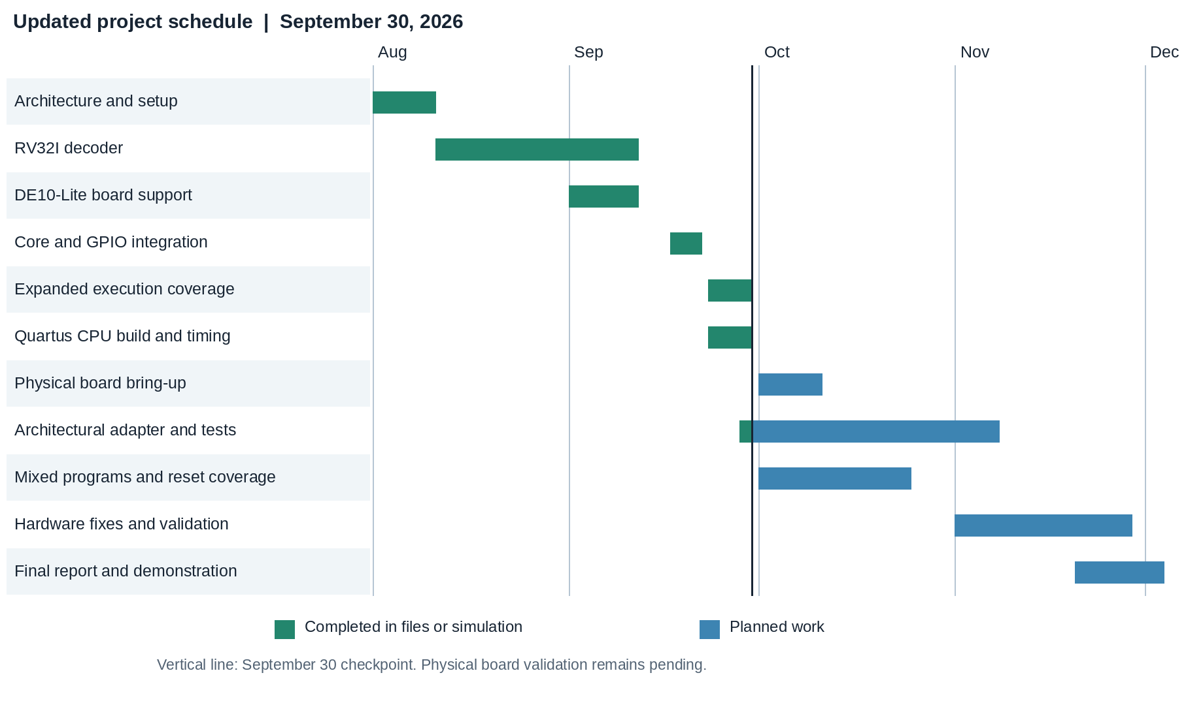
Current Gantt chart for Progress Report 4
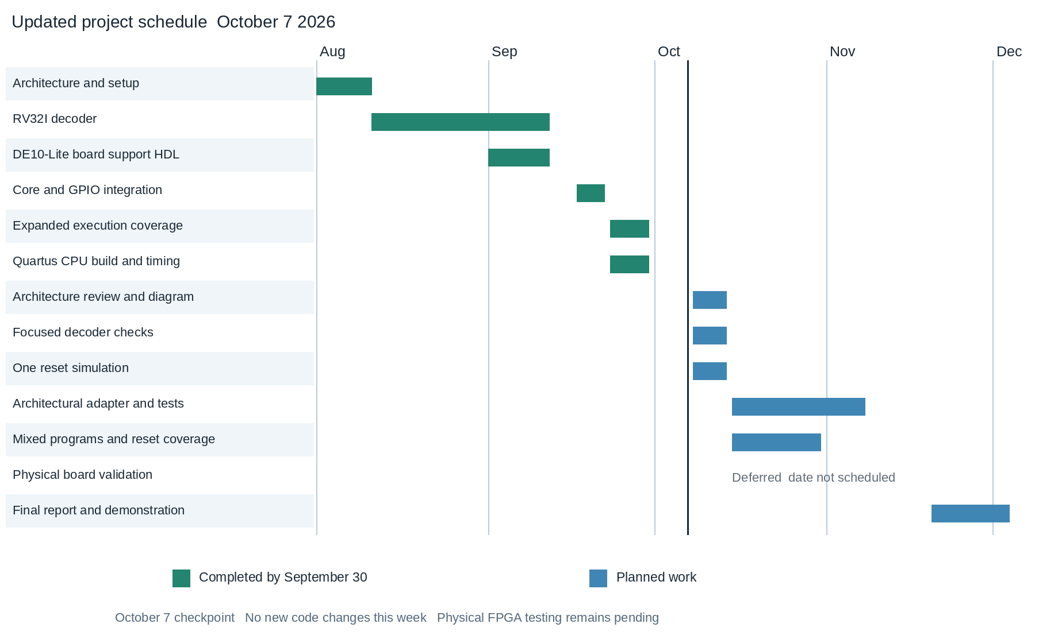
The completed milestones remain unchanged from September 30. October 8 through 14 is reserved for the three smaller HDL and architecture goals. Board testing is deferred; the December 4 final demonstration remains a planning target.

Existing HDL and architecture evidence
Reporting period September 30 through October 7 2026. I made no new code changes during this period and have not physically tested the FPGA. The excerpts below document the existing implementation and earlier simulation results.
Core request and retirement logic
Source rtl/core/rv32i_core.vhd lines 86 through 105
i_req_o <= '1' when state = FETCH_REQ and reset_i = '0' else '0';
d_req_o <= '1' when (state = MEM_READ_REQ or state = MEM_WRITE_REQ) and
reset_i = '0' else '0';
d_write_o <= '1' when state = MEM_WRITE_REQ and reset_i = '0' else '0';
retire_valid_o <= '1' when state = WRITEBACK and reset_i = '0' else '0';
This logic suppresses new bus requests and retirement while reset is active. It provides a concrete starting point for the planned reset test. A store accepted before reset must be considered separately from a request suppressed by reset.
Architecture already defined
The CPU is a non-pipelined, multi-cycle RV32I design with one instruction in flight. On a rising edge with reset asserted, the core sets PC to 0x00000000 and enters FETCH_REQ. Register x0 always reads zero and ignores writes; a load to x0 still accesses memory and can fault. Program ROM spans 0x00000000 through 0x00003FFF, and RAM spans 0x00010000 through 0x00013FFF. GPIO uses exact word addresses: LED 0x40000000 (LW/SW), switches 0x40000004 (LW only), and status 0x40000008 (LW only). The board wrapper ties status to zero. Source: docs/architecture.md; checked against the core, register file, memory map, memory bus, and GPIO HDL.
Earlier simulation evidence from September 30
tb_decoder passed: 270612 decode cases
tb_memory_bus passed
tb_core_execution passed
Directed execution suite passed: 13 programs
Source docs/validation/2026-09-30/execution.txt. These are saved results from the previous report, not a new simulation run. The architectural adapter still needs shared ROM image loading and initialized RAM data support, and upstream tests remain pending.
Repository revision be6eec4 September 30 2026
Repository https://github.com/schady23/risc_v_32i

Goal 1 architecture review evidence
Completed October 12 2026. This review documents the existing HDL and clarifies the architecture description. It is separate from the September 30 through October 7 reporting period above; it does not represent a new simulation run or physical board test.
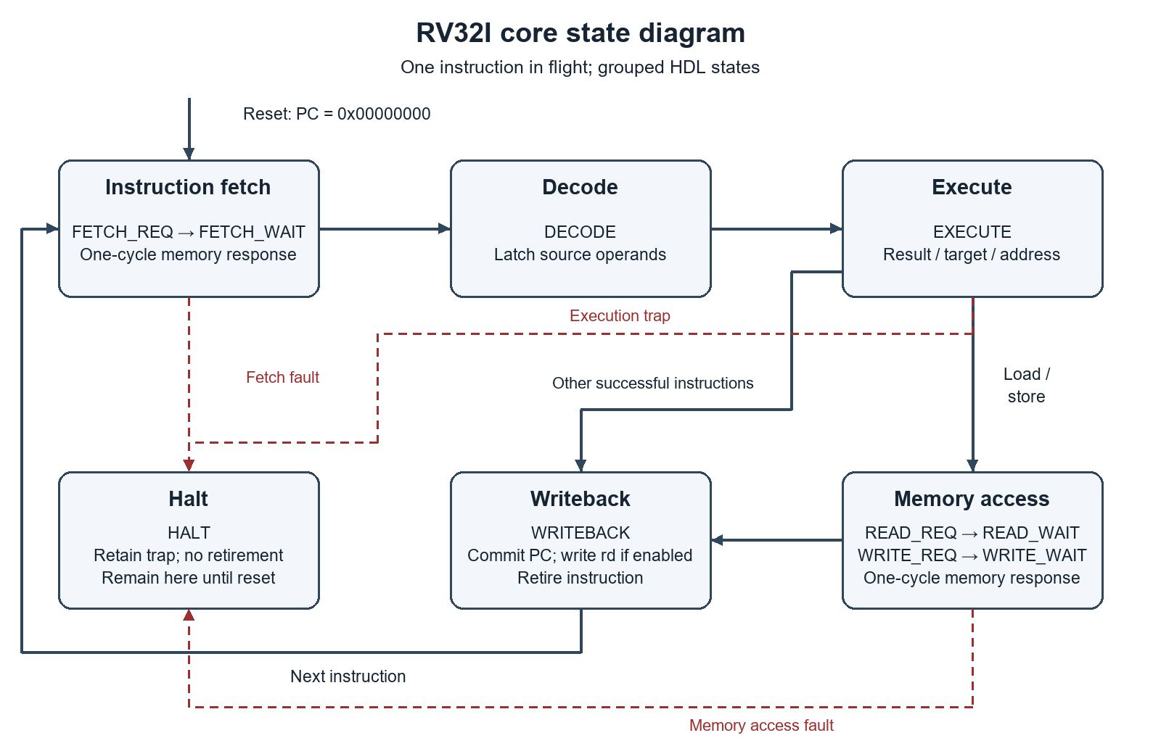
Figure 1. Core states grouped into six sequential stages. Request accepted at edge N; registered data or fault status is consumed by the core at edge N+1. A valid store commits at edge N and retires after a successful response. All states return to instruction fetch on reset; HALT otherwise remains latched.
The October 12 review confirms reset PC zero, x0 protection and fixed memory timing. Its GPIO entries describe that date. October 14 work replaced GPIO with JTAG UART at the same three addresses and added instruction fetch from RAM. The current contract is in docs/architecture.md and docs/uart.md; the state diagram still applies.
Sources and detailed HDL checks: evidence/goal-1-hdl-review.md. Diagram: evidence/goal-1-state-diagram.png; editable source: goal-1-state-diagram.mmd. Current source remains the authority for the implemented address map.
Goal completion update October 15 2026
All three next-week goals are complete. Goal 1 completed October 12; decoder and reset checks completed October 15. The following pages contain their waveform evidence. These dated additions follow the original September 30 through October 7 reporting period.
Goal 2 decoder simulation complete
Completed October 15 2026. I added tb_decoder_focused with seven fixed instructions and assertions for legality, raw register fields, the immediate and every control field. All seven cases pass at 70 ns; the exhaustive decoder test also passes 270,612 cases.
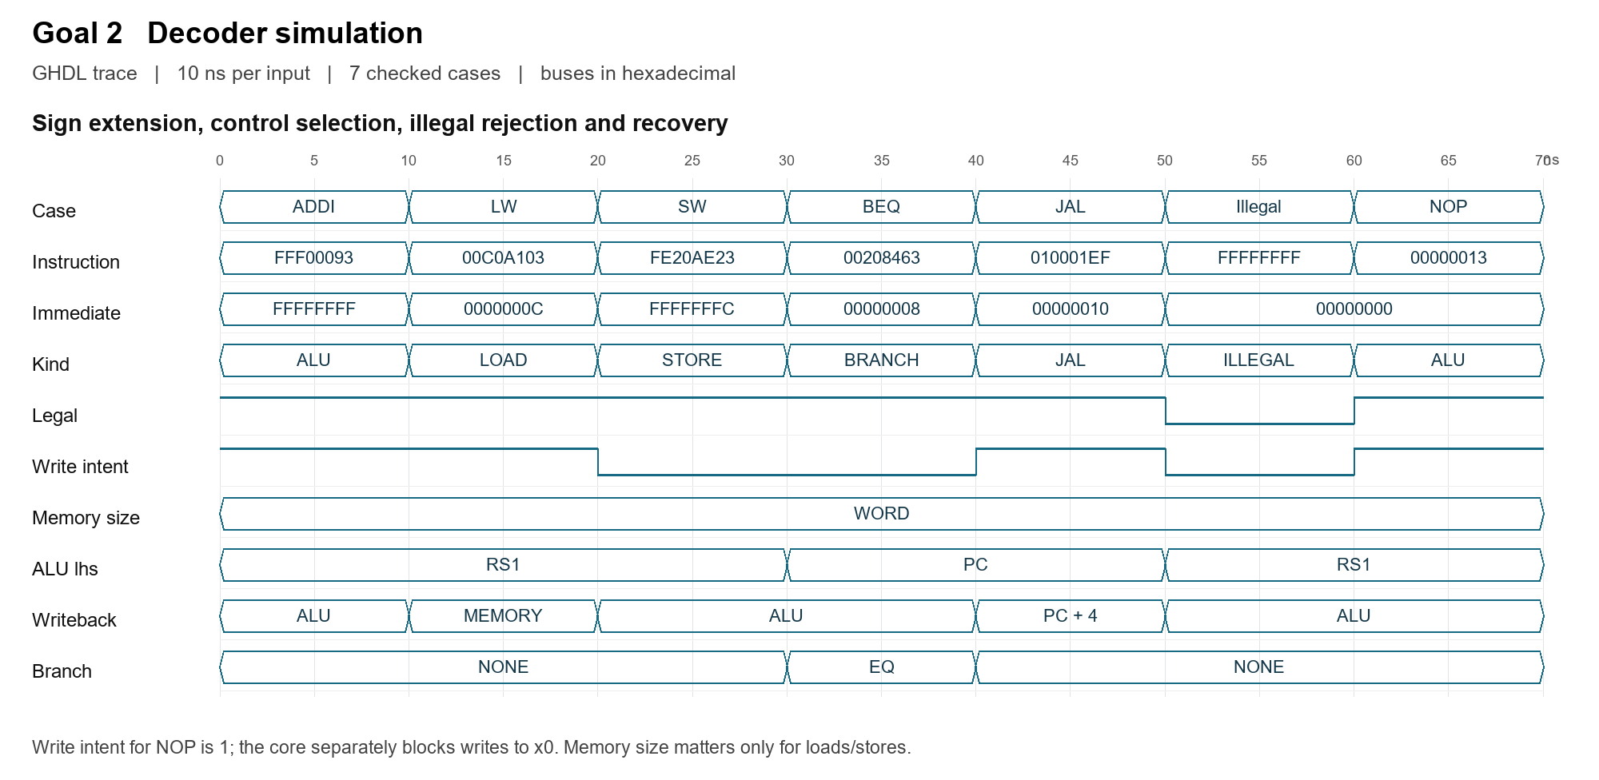
Figure 2. Actual GHDL VCD transitions. Each instruction is held for 10 ns; assertions sample after 1 ns. The decoder is combinational, so this is a sequence of input cases rather than CPU clock cycles.
The waveform shows FFFFFFFF for ADDI -1 and FFFFFFFC for SW -4, confirming sign extension. LW and SW select word accesses. ADDI, LW and JAL request a destination write; SW and BEQ do not. BEQ selects the PC and equality comparison, while JAL selects PC plus 4 for writeback.
At 50 ns, FFFFFFFF is rejected: legal and write intent drop to zero and the immediate clears. NOP restores legal decoding at 60 ns. NOP still has write intent, but the core separately blocks writes to x0. Default memory-size fields on non-memory instructions do not cause a memory request.
Saved evidence: evidence/goal-2-decoder.ghw and .vcd; goal-2-decoder-waveform.png; goal-2-decoder-simulation.txt. Source: sim/tb_decoder_focused.vhd and rtl/pkg/rv32i_pkg.vhd. GHW preserves typed records; VCD exposes enum-position aliases translated into names in the figure.
Goal 3 reset simulation complete
Completed October 15 2026. The focused test uses the actual core, register file, memory bus and RAM with an independent ROM. Three injected resets pass all assertions; the test finishes at 1165 ns.
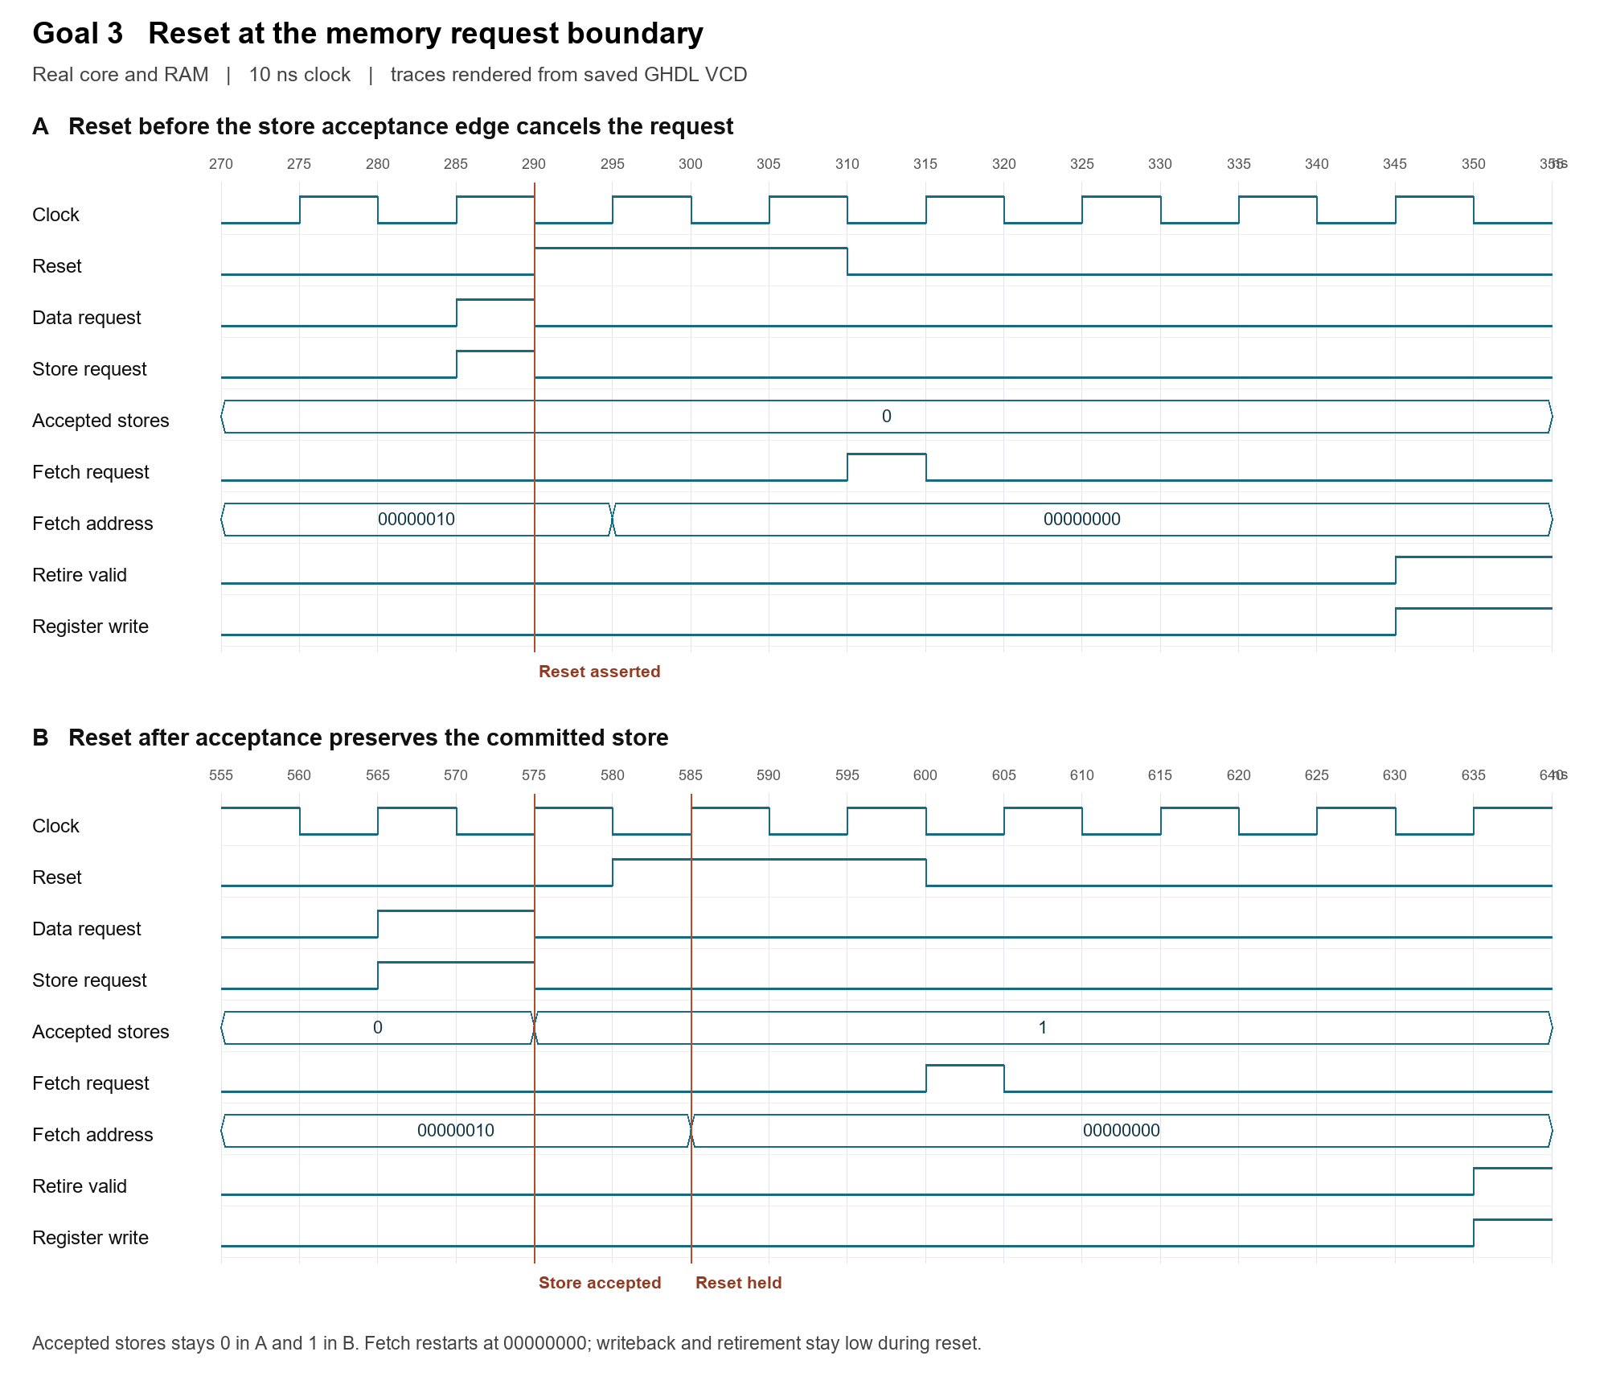
Figure 3. Store request boundaries in the saved GHDL trace. All instruction/data requests, register-write enable and retirement are suppressed while reset is asserted.
Panel A shows reset at 290 ns, before the store can be accepted at a rising edge. The request drops and the accepted-store count stays zero. Releasing reset at 310 ns starts a fetch at address zero. Panel B shows a store accepted at 575 ns followed by reset at 580 ns; the count stays one, and a later load reads 0x55 from the preserved RAM word.
A third reset at 930 ns suppresses an ADDI writeback before its commit edge. After each restart, ADDI x7,x6,1 returns 1 even though x6 previously held 0x55, confirming register clearing. These cases cover the focused goal; reset across every state and physical board timing remain future work.
Saved evidence: evidence/goal-3-reset.ghw and .vcd; goal-3-reset-waveform.png; goal-3-reset-simulation.txt. Source: sim/tb_core_reset.vhd. Full transcripts and reproduction instructions: evidence/report-4-completion.md.

